CONVERT 40 FROM BASE 8 TO 2

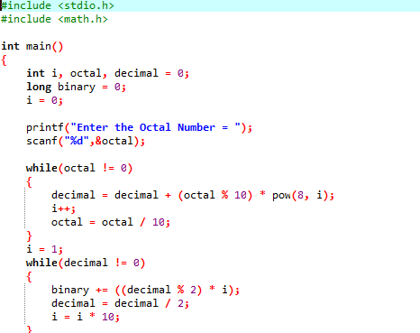

OUTPUT

